Capstone Strategic Project

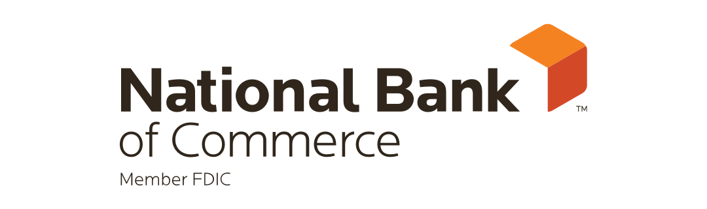

Presented by:

Eric Albrecht

Chief Operating Officer
2/27/2023

ABSTRACT

Title: Creating and using a balanced scorecard to enhance the future performance of National Bank of Commerce (NBC).
Author: Eric Albrecht
Capstone Advisor: Scott Earwood
Course: ABA Stonier Graduate School of Banking (Wharton)
Background and Problem Discussion: The effect of non-financial variables on the financial performance of NBC has become significant. Having knowledge of our customer satisfaction, internal business processes, organizational Learning and development directly influences our financial indicators. We can no longer rely on our non-financial variables to continually produce sustainable business practices in a rapidly changing financial environment.
Purpose: The purpose of this project is to create a real time Balanced scorecard to assess the performance of NBC across key performance indicators (KPI’s) in the financial and non-financial framework of the bank.
Method: Internal review and peer data are the methods. Primary data is financial and non-financial statistics collected from NBC internal scorecards, associate feedback, senior leadership insight, public sources for peer organizations, and customers of NBC.
Analysis: We have chosen to show how the balanced scorecard can be used to assess performance of NBC in non-financial variables to provide information around sustainability of business practices to all stakeholders – internal and external.
Conclusion: The analysis is designed to show only marginally the impact of non-financial perspectives on financial performance. Analysis also shows that in assessing performance of NBC some critical non-financial factors such as customer satisfaction, efficient internal business processes, and the quality of associates play a more crucial role than originally anticipated. Of specific interest, our commercial loan process and the turn-around time on loan processing and disbursement. Commercial loans are a core driver of NBC’s profitability and for which we historically failed to adequately address performance gaps within the process. The project revealed that the balanced scorecard framework brought forth data that was not being reviewed and will have an impact on our sustainable business practices.

ACKNOWLEDGEMENTS
I would like to thank the many people who in different ways have supported me in my ABA Stonier Graduate School of Banking journey. First, I would like to thank my advisor, Scott Earwood for his insightful direction and support during the period of writing my capstone project. I would like to express my gratitude to my senior leadership team, Performance Trust, and my fellow associates who graciously accepted my request to answer my questionnaire and to grant me time to interview them. I would also like thank the customers of NBC who allowed me to gather information with intent to help improve customer satisfaction and enhance our overall customer experience. Special thank you to Seth Mathews for his technical help and discussions on creating dashboards in Microsoft Business Intelligence. Finally, I would like to thank my wife and kids for their complete support in allowing me time to complete this project.

ACRONYMS
NBC | National Bank of Commerce
PT | Performance Trust
KPI | Key Performance Indicator
BSC | Balanced scorecard
EPS | Earnings Per Share
HR | Human Resources
SLT | Senior Leadership Team
BLT | Bank Leadership Team
ROE | Return on Equity
ROA | Return on Assets
SLA | Service Level Agreement
CRM | Customer Relationship Management
CSI | Customer Satisfaction Index
HC | Human Capital
CR | Customer Retention
BPR | Business Process Review
RPFTA | Revenue per full time associate

Table of Contents
Contents
Executive Summary 8
Introduction and Background 10
NBC Banking Locations 12
Identifying a Strategy 12
Balanced scorecard Framework- 4 key areas 16
Financial 16
Customer 16
Non-Financial/Internal Business Process 17
Learning and Development 17
Financial and Non-Financial Impact Summary 22
Financial Impact 23
Analysis of Financial Performance 24
Analysis of Customer Perspective 28
Analysis of Internal Business Processes 30
Analysis of Learning and Development Perspective 31
Summary of Perspective Findings 32
Correlation between Internal Business Processes and Customer Perspectives 33
Correlation between Learning & Development and Internal Business Processes 33
Conclusion 34
Bibliography 35
Appendixes 36
Appendix A: NBC CORPORATE REPORT CARD 36
APPENDIX B: QUESTIONNAIRE/SURVEY QUESTIONS FOR BANK CUSTOMERS 37
APPENDIX C: QUESTIONNAIRE FOR CHIEF FINANCE OFFICER (CFO) 39
APENDIX D: QUESTIONNAIRE FOR HUMAN RESOURCES DIRECTOR 40
APPENDIX E: NBC ASSOCIATE SURVEY 41

CHAPTER ONE

EXECUTIVE SUMMARY
AND
INTRODUCTION

“If you don’t know where you are going, you’ll end up someplace else”
[Yogi Berra]

"If you can't measure it, you can't improve it"
[Peter Drucker]

Executive Summary

This capstone strategic project is designed to assist National Bank of Commerce (NBC) with creating a real time balanced scorecard. The objective of the balanced scorecard is to assess the performance of NBC in several dimensions and measures. NBC has a solid grasp on our financial perspective; however, we have identified the necessity to seek balance between our traditional financial perspective and our non-financial perspective segments of our business. These include customers, internal business processes, and learning and development. Upon development NBC will utilize the balanced scorecard to track short-term financial results, while monitoring our non-financial perspectives to generate future sustainable growth strategies.
NBC has historically measured the performance of our organization against the financial perspective of our peer banks. This approach attempts to measure the performance and competitiveness of NBC against peer banks using financials and does not take into consideration the customer perspective, internal processes, and learning and development perspectives. These are critical in using the BSC to assess a holistic view of the performance and competitiveness against long term sustainable growth. Ultimately, this creates the most applicable circumstances to apply the BSC framework to. These four key aspects are financial perspective, customer perspective, internal business process perspective, and the learning and development perspective. While financial performance is a major indicator of success, it fails to provide a "big picture" assessment of sustainable business performance. We must recognize that other factors may be equally important in determining success and often are linked to sustainable financial performance.
A major factor that motivated me to pick this project is the absence of a balanced scorecard model that assesses performance using the non-financial perspective to ultimately drive sustainable business practices into the future. The issue is we are making decisions based off the past10 years, which has seen very little volatility in our markets and most financial institutions were profitable. The industry has failed to use technology to grow with the changing times and still relies heavily on the use of financial factors in assessing the success of strategies and how that relates to profitability. We have failed to incorporate the non-financial perspective to fully understand the long-term sustainability and future profitability. COVID-19 has pushed NBC, our industry, and our customer base fast forward roughly 10 years. Therefore, this is a factor in assessing true performance of NBC and competitive peer banks with respect to sustainable strategies and goals. Additional external factors of inverted yield curves, rising rates at record paces, staffing, competition, recession fears, and supply chain management are all factors that will eventually have an impact on sustainability. To better understand all factors, the balanced scorecard will be used to give a more holistic approach to assessing performance of NBC. We will attempt to utilize certain non-financial perspectives against select peer banks, with the understanding it will be more challenging to gather the information and comparatively measure.
Somewhat surprisingly (especially given all the data available) there is very little research as to whether the balanced scorecard method has worked well in terms of its implementation and its usefulness to financial organizations. Various sources (Kaplan and Norton) have made some efforts to demonstrate the impact of the balanced scorecard, but their approach was to use largely subjective cases. I found additional cases from other industry experts, which reported that 27% of organizations surveyed built and tested models within their measurement systems, and that these 27% achieved 2.95% higher return on assets and 5.14% higher return on equity over a measured period of 24 months. It is key to note that these were not financial institution measurements. Additional research through Google search suggests that organizations who managed through ‘balanced’ performance systems perform better than those that are not. Most of the material refers to organizations making consistent use of financial and non-financial efforts and were able to link those efforts to operational metrics and as a result had higher returns than those that don’t. The overall return measurements were not shared on those examples. One study did show that the use of a balanced scorecard system as a management control tool reduced overhead costs by roughly 25%. NBC would like to ultimately show that by using the balanced scorecard approach we can enhance financial and non-financial performance indicators to ultimately remain an independent community bank.

Introduction and Background

National Bank of Commerce has enjoyed a long and prosperous history. The bank, originally chartered as Union National Bank of Superior on February 7, 1934. It replaced the already closed United States National Bank. It officially opened for business on April 16, 1934.
A year and a half later, Union National Bank purchased the American Exchange Bank on December 31, 1935. Five years after that, the bank took another major step by changing its name and location when it purchased the National Bank of Commerce of Superior and changed its legal name to National Bank of Commerce in Superior. In September 1972, NBC purchased the Poplar State Bank and its branch in Solon Springs, Wisconsin, and established both as branches.
Then, in 1979, NBC began construction on its new headquarters in Superior. Built at 1127 Tower Avenue, it was just down the block from the previous location. 1127 Tower Avenue remains today as the main branch and headquarters for NBC. After NBC moved into the new bank in 1980, it continually grew each year. But in 1998, the bank took the necessary steps to ensure unlimited growth. A holding company was established – NATCOM Bancshares, Inc.
Only two years later, a new location opened at 1314 E Superior St. in Duluth, Minnesota. This office would be NBC’s first outside the state lines of Wisconsin. Since then, NBC has continued to grow with locations opening in Superior – Midtown at 2822 Tower Ave. in March 2003 and in Hermantown, MN at 4105 Richard Ave. in December 2004. In 2008 NBC purchased the assets of Community Bank uniting the two banks. In 2019 NBC completed its largest acquisition in history acquiring Republic Bancshares, Inc. This added four additional locations in Duluth, MN, one location in Esko, MN and one location in Hibbing, MN. With this acquisition NBC was now the largest community bank in the Twin Ports Region with assets exceeding $1 billion and an expanded market presence.
Most recently in June of 2022 management made the decision to move forward with loan production office (LPO) located 100 miles from our headquarters. We took this opportunity to expand based on finding key market talent and utilizing a vendor to identify opportunities within a market outside our Twin Ports demographic. This model has proven very successful as we have been able to penetrate this market with $12MM in deposit growth and $40MM in loan growth with a single commercial lender that is completely supported from our main branch location in Superior, WI.

NBC Banking Locations
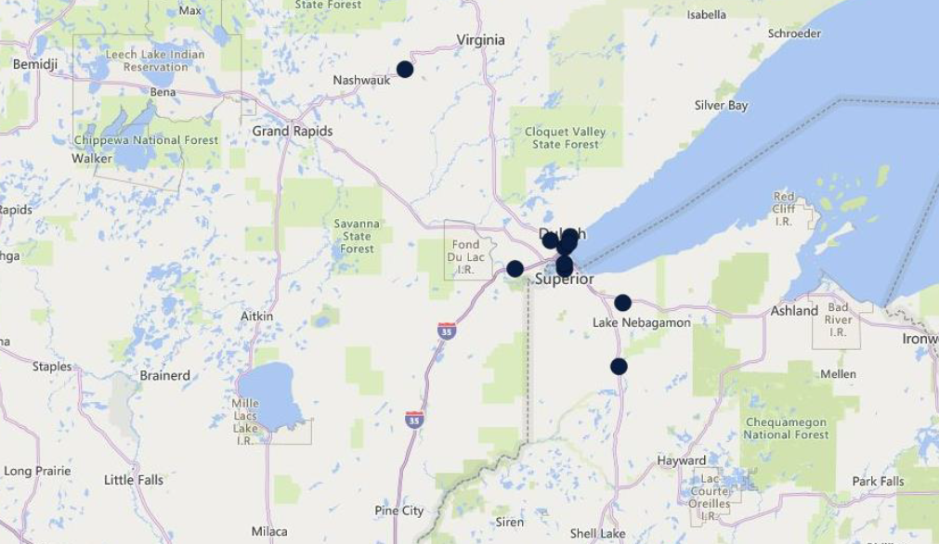

Identifying a Strategy

Map it! NBC was continuously struggling in our strategic planning sessions. Stepping back, we made the decision to create a strategy map and then take the map and build the balanced scorecard. This strategy leads us down the path of identifying the key metrics that will drive sustainable growth and success when executed appropriately. As an organization we recognize our challenge or pitfall is aligning operational improvement activities to strategic priorities and keeping the top priorities our main priorities. Consequently, most of our previous efforts failed to be properly measured, thus would not show up in tangible results.
The Strategy map represents how we will execute. The strategy map details out the objectives needed to execute the strategy and links all the objectives to maintain prioritization. The Strategy map will be the primary tool for clear communication and will help identify the key metrics to monitor strategic execution.
The balanced scorecard is part two of the process that will translate our strategies into action. The balanced scorecard gives a balanced view of the four perspectives and how well the organization is driving execution and how successful the desired results are. The four perspectives in the balanced scorecard and strategy map will provide senior management and the Board of Directors a more balanced view of the organization. These metrics go beyond financial measures to include financial, non-financial/internal processes, customer, and learning and development.
As an organization we are fully committed to taking one to three years to create, implement, and properly execute to achieve the results. We do not want this to fail with the burden of administrative overhead and misaligned metrics. Our balanced scorecard will help us do the following:
- Clarify Strategy – our discussions and thoughts must clarify what are we trying to accomplish and why. What decisions can be made from the data we are trying to collect and how does each associate within the organization fit into the strategy. The strategy map will bring down the departmental silos and show associates how they can contribute to success.
- Translate strategy into action and execution – the strategy map, combined with our implementation plan will give everyone a clear road map showing how the strategy will transform into action. The balanced scorecard will be used to keep the organization on track and monitor execution and sustainability.
- Align business units around the strategy – we have silos created by leaders that are more concerned about having their opinion heard and if it is not heard they dig their heels in and create organizational disfunction. The strategy map and implementation plan will give opportunity for upfront feedback and keep the focus on the strategic target. This will align cross functional duties and departments to work together and minimize the silos and create accountability to completion.
- Communicate the strategy to all levels within the organization – throughout our associate engagement feedback a major area of improvement identified was cascading the message throughout the entire organization. As a senior leadership team, we are making a conscious effort through this process to ensure everyone gets the message of what are we doing and why are we doing it. Managers will be held accountable if a gap in the message is identified throughout the implementation process.
- Monitor and manage strategic execution – management has fallen into the practice of spending too much time looking at results and not enough time monitoring strategy and execution. We become interested in performance results and lose track of what is important. Using our new strategy map and balanced scorecard approach allows us to keep the central focus on our strategic leadership of guiding the organization. It also elevates accountability across the organization to measure and improve our internal business processes.
Building our strategy map and balanced scorecard commits us to following a process and will help us with the change management process in our industry, which is seeing change happen faster than ever before. Our organization needs to be scalable while having strategic initiatives that anchor us through all economic cycles.
The first thing we asked ourselves is what gets in the way of our success? Neither the strategy map nor the balanced scorecard will guarantee success. We can ultimately fail by having the wrong strategies that increase the risk to the organization. We can also fail by simply not executing what strategies we set forth in any given environment. The senior leadership team met with a consultant to determine what could get in the way of our success. We came up with some of the following:
- Failure of senior leadership to commit and be the stakeholders
- Lack of board of director support
- Inability to present “What are we doing and why are we doing it?”
- Too many priorities
- Using the wrong data to make decisions
- Fear of the unknown
- Time and effort understated for any given project
- Culture
- Accountability
- Communication
- Chasing shinny objects “non priorities”
As a leadership team identifying these areas of concern and reflecting on past projects showed all these topics created stress, delay, decreased associate morale, less than desirable results, or failure in the projects we associated them with. Our commitment became unified that we must create and execute the strategy map and the balanced scorecard.

Balanced scorecard Framework- 4 key areas

Financial

The financial perspective deals with how the organization appears to its shareholders. NBC currently has a robust corporate report card that we will continue to use going forward to measure financial performance of our organization and how we rank against our peer group.
Typical financial measures will include ROE, ROA, asset book (corporate, commercial, business banking, retail), fee income, cost of funds, cost efficiency, asset utilization, and NPL%. NBC will continue to use its corporate report card to track these measurements.

Customer

Customer feedback scores are more important now than ever. With the increased competition, clarity on needs and defining the proposition for the target segment is important in our strategy map. The value proposition essentially includes the product and service attributes, the image of the bank, and relationship quality. It is critical we recognize the difference in approach for the commercial, small business, mortgage and retail banking segments when defining the customer objectives and measurements. The customer-related measures will include customer acquisition, channel transaction mix, cross-sell percentage, products per customer, customer satisfaction index, and customer attrition. Product features, image, and relationship strength are key measures for a successful customer and product strategy.

Non-Financial/Internal Business Process

From the point of identifying the customers’ needs to the point of having the needs fully satisfied, the process framework of the bank needs to excel in the areas of innovation, operational excellence, and delivery of quality service. Continuous improvement to internal processes serves as the backbone for meeting and exceeding customer expectations. Not only should the process perspective focus on the products and services for the customer, but it should also set the right priorities for the channels – an area that is increasingly becoming important, especially when we live in an era of mobility and anywhere, anytime banking. Since this is reflective of efficiency and productivity, we are seeking to measures operating cost, process SLA, branch transaction cost, efficiency ratio, and alternative channel penetration. Risk tolerances will be established and measured by regulating bodies, internal audit ratings, and compliance reviews. Each business unit will have a well-defined set of metrics to evaluate performance and operational risk on a consistent and real time basis. An additional component that is not covered in this paper is that we will be developing a full facility plan that will set forth a strategy for our existing and future branches. This strategy will consider financial and non-financial perspectives surrounding how the branches are geographically and architecturally positioned.

Learning and Development

The perspective has shifted around the organization’s objectives toward human competencies, technological infrastructure, and the calls for action, it pretty much serves as the foundational layer for NBC’s organizational philosophy and priorities. Being a community bank that embraces a customer centric-driven culture could be quite a different ball game than having a process or performance-centric organizational culture. Measurement of training days per associate, career pathing, turnover ratios, overtime hours, and associate satisfaction will drive the L&D perspective. Additional technology related measures will include key milestones of technological initiatives and the utilization rates of all technology products for strategic growth and not as an operating cost. To remain relevant, we need to attract and retain the top talent in our markets.
Ultimately, the benefit of the balanced scorecard is that it forces our organization into a level of focus that encompass both leading and lagging indicators.

Balanced scorecard Implementation

As with any strategic framework thought process, the balanced scorecard presents opportunity for successes and challenges that we must consider. The main challenges NBC has identified in the concept of creating the balanced scorecard are:
- It could take too much time to set up across the organization.
- Associates fail to never fully understand it and therefore fail to execute or benefit from it.
- It becomes too focused on financial performance measures above all else.
- It's too internally focused, almost completely ignoring the industry environmental trends or competitive aspects of running the organization.
- The organization cannot keep up with the pace of change.
- The priorities are not what’s being worked on.
- Invalid or inaccurate data being used to make decisions.
NBC has committed to the following implementation path to start simple and measure effectiveness over the first 12 months.
- Cleary defined the KPIs within each key segment to measure.
- We are currently researching partnerships to create a data collection plan that is standardized, accurate, reliable, and real time.
- Select an industry partner to take our data collection and put it into a balanced performance dashboard.
- Regularly communicate the results of the balanced scorecard to all stakeholders and ensure that the information is accessible and understandable.
- Continuously review and improve the balanced scorecard to ensure it remains relevant in driving performance and strategy execution.

Balanced scorecard- Implementation Mistakes

Working with our consultant they warned us that organizations tend to look at the balanced scorecard as four perspectives that you simply 'slot your strategic goals' into. When they visualize the Balanced scorecard, they think of something like this diagram:
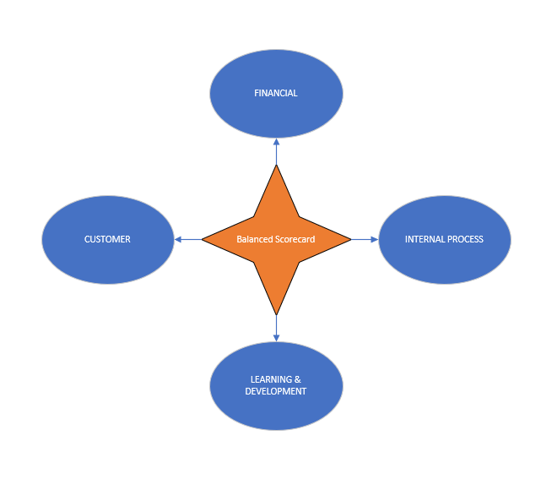
Four simple perspectives that link equally together to give you a balanced scorecard of your organizational performance. Each perspective containing a list of strategic objectives, projects and KPIs which you then attempt to place into action to achieve results. The end goal being to balance each perspective and achieve targeted results of improved performance. Fundamentally this leads to failure at some point in the process.
The balanced scorecard is not a series of “equally” weighted perspectives. It is a process whereby, starting at the bottom, you work your way upwards through each perspective with a goal of delivering organizational growth through financial gains.
Each perspective needs to unlock our ability to deliver effectively for the one above it. So instead of the previous diagram, we need to visualize the Balanced scorecard from a strategy mapping point of view:
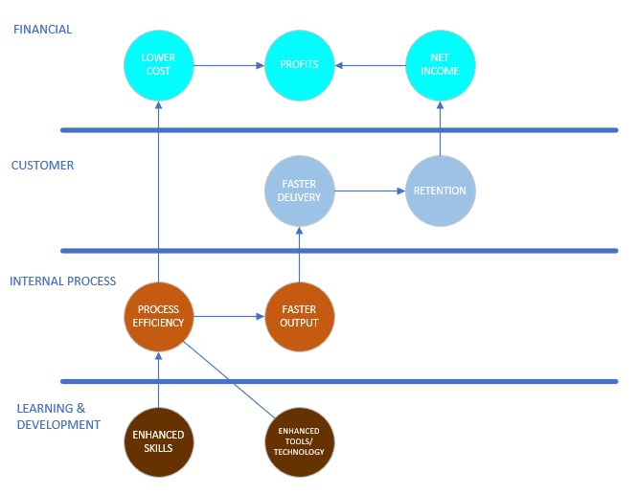
If we are able follow the steps in the diagram, we understand that the ultimate end of the journey is to increase profitability, financial. Another way to think about the balanced scorecard is as a series of leading and lagging steps (like proactive and reactive KPIs), as they apply to our strategic objectives and projects.
The customer, internal processes, and learning and development will be our leading step, as they will facilitate the delivery of our one and primary lagging step, which is our financial performance. Essentially this is where we need to be cautious of the balanced scorecard, that it essentially 'ends' at making more money and you can lose site of the leading indicators you are trying to manage.

Why this approach to implementing the balanced scorecard makes sense to NBC.

Our ability to learn and grow will directly dictate our ability to better manage our internal processes. In turn, as our internal processes improve, this will have a positive impact on our customers as well as directly reducing our costs. The combined benefit of lowering our cost/higher customer engagement will lead to our end goal, increased profit, and sustainable financial returns.
The balanced scorecard isn't about distinct perspectives, it's about the strategic process. When properly executed, it ultimately should lead us to a path that equals success. When implemented in the correct way, the balanced scorecard can be immensely powerful in helping our organization to:
- Create a tangible roadmap from the current state to a more successful future state.
- Identify major roadblocks and areas where we lack the critical competencies to proceed to the next stage.
- Articulate how our goals will directly help the organization to move upwards through the stages efficiently.
- Prioritize business activities in the order they need to be tackled to allow the most efficient progression through each stage.
- Cut down on the amount of starts and stops throughout the process.
- Identify gaps within each business units’ internal processes.
- Hold everyone in the organization accountable to their roles and responsibilities.
Specifically, the main benefit of the balanced scorecard is likely to come less from the creation of the perspectives themselves, but rather from the strategic management process using the perspectives as executable and measurable stages.

Financial and Non-Financial Impact Summary

This section will provide further detail into the measures of how the BSC framework will be used – internally and externally - in assessing the sustainable performance of NBC. The key function of the bank is financial intermediation where we take from the surplus and give to the deficit. To effectively execute this function, we need to perform very well in the balanced scorecard framework. It is generally known that, to get low cost and cheaper funds to lend, we must grow our current deposit accounts from consumers and business depositors. To achieve this, we must have the right internal processes and controls that will deliver high quality and efficient services to our valued customers to attract and retain them. For efficient execution of the internal processes, NBC must have motivated, experienced, and skilled associates. This will ensure we have satisfied customers and in return be able to grow and retain them. This will ultimately impact our organizational sustainable financial performance.

Financial Impact

We establish an initial budget of $25,000 for this project. When we saw the value in the project and how the strategy map could get us to where we needed to go, we said yes. The budget thought process changed to get this completed and make it a number one priority. The risk of not doing this far outweighed any cost projection that we ran.
This was what he had to say for each of the perspectives when we considered the financial and non-financial impact of the four measures in assessing our banks’ strategic performance and why we must do this:
• Under financial we said, “Yes because of its importance to growth, sustainability, and survival.”
• Under customer perspective we said, “Yes because of the impact on all other performance metrics.”
• Under internal processes we said, “Yes because to attract and retain customers, we need to ensure that internal processes are both effective and efficient.”
• Under learning and development, we said, “Yes because we are in the service industry, and the strategy that makes the difference is the “people strategy.”
In terms of our bank’s strategic objectives for the various KPIs this was what we said, “Our strategic objective in terms of financials is to improve on returns to all stakeholders: shareholders, associates, and our communities within which we do business in.” NBC has created the following strategic strategy map.

NBC STRATEGY MAP
FINANCIAL | SHAREHOLDER VALUE  INCREASED REVNUE
CUSTOMER | CIF GROWTH – Market Specific  CIF CUSTOMER LIFE - > 7 years
INTERNAL PROCESS | Operational  Strategic Operating goal of 52% or better efficiency ratio | Customer  Retention  Customer Satisfaction  Index (CSI)  CSI >7 | Technology  Use technology to create efficiencies | Community  Improve the communities we serve through involvement and commitment
LEARNING AND DEVELOPMENT | Human Capital | Information Capital | Organizational Capital
LEARNING AND DEVELOPMENT | Skills  Training  Knowledge  Retention | Data  Systems  Measurements | Culture  Leadership  Alignment  Execution

This therefore creates the links between the four dimensions and how they support each other to create value for the customer and move towards the goal of sustainable profitability.
The overall strategy of the bank is to increase shareholder’s value through customer acquisition and organic growth through the penetration of client product mix. We are also seeking to improve asset quality across all loan categories.

Analysis of Financial Performance

Under financial perspective, the following measures/metrics were considered and will be incorporated:
1) Operating Income (Market share).
2) Return On Equity (ROE).
3) Return On Asset (ROA).
4) Earnings Per Share (EPS).
These are good indicators of the financial health of our organization since they measure how
efficiently we are utilizing assets and the value they are returning to shareholders on their investments. In theory a business that is financially healthy will consistently return high ROA, EPS, and ROE year in and year out. These measures will therefore give information to shareholders on the state of the businesses they have invested in or are considering an investment in. Operating income is a measure of our earnings power from ongoing operations, that is equal to earnings before deduction of interest payments and income taxes. It is also called operating profit or EBIT (earnings before interest and taxes). This therefore has strong bearing on the performance of management, and it indicates the degree of operating leverage for our organization. The return on assets is an indicator of how profitable we are relative to our total assets. ROA gives an idea as to how efficient management is at using assets to generate
earnings. We will calculate it by dividing annual earnings by total assets, ROA is
displayed as a percentage.
The assets of our company are made of both debt and equity. Both types of financing
are used to fund the operations of NBC. The ROA figure gives investors an idea of
how effectively we are converting investments into net income. The higher the ROA number, the better, because the company is earning more money on less investment. NBC achieved an S corp adjusted ROA of 1.39% for the period of Jan-Dec 2022 and lead our peer group.
Return on equity (ROE) is an indicator of profitability. It is the most important profitability metric. Return on equity reveals how much profit is earned in comparison to the total amount of shareholder equity found on the balance sheet. Shareholder equity is equal to total assets minus total liabilities. It’s what our shareholders “own.” Shareholder equity is a creation of accounting that represents the assets created by the retained earnings and the paid-in capital of the owners. A higher return on equity is more likely to be one that can generate cash internally. NATCOM which is the holding company for NBC achieved an ROE of 15.39% for the period of Jan-Dec 2022 and lead our peer group.
Earnings per share (EPS) is defined as our net profit for a particular period divided by
the number of ordinary shares. Basic EPS is computed by dividing net profit or loss
attributable to ordinary shareholders by the weighted average number of ordinary shares
outstanding during the period. EPS is a standard measure often used to assess
profitability. NATCOM had a pretax EPS of $275.29 for 2022.

National Bank of Commerce (NBC)
FINANCIAL PERSPECTIVE
Strategic Objective | Measurable Strategies | Performance
Top 25% Peer Group ROA | Net Operating Income | $19MM +
Increase Earnings Per Share | EPS | $400
Utilize Organic & M&A Growth Models | C- Corp ROE goal | *1.0%
 | C- Corp ROA goal | *1.5%
 | Asset Size | $2 billion
*We are an S-Corp, but we adjust to compare C-Corp ROA and ROE to peer data
CUSTOMER PERSPECTIVE
Strategic Objective | Measurable Strategies | Performance
Enhance Customer Experience | Customer Satisfaction Index (scale 1-10) | >7
Omni Channel Delivery | Customer Retention | 0.92
Knowledgeable Associates | Channel Usage | >75%
Branch Footprint Strategy with defined delivery channels
INTERNAL PROCESS
Strategic Objective | Measurable Strategies | Performance
Enhance Technology Use | SLA for Commercial Loan | 60 days or less
Improve Operational Performance | SLA for Teller Transaction | Under 2 mins
Enhance the Customer Experience | SLA for Deposit Openings | 30 minutes or less
Efficiency Ratio | All four perspectives | 52% or better
LEARNING AND DEVELOPMENT
Strategic Objective | Measurable Strategies | Performance
Retain top tier talent | Emplify Participation | 80%
Establish Career Pathing | Emplify Results | Engaged
Be the Employer of Choice
Staffing Turnover | Teller Turnover | Reduce from 40% to 20%
 | Total Staff Turnover | <5%

Analysis of Customer Perspective

For NBC to survive and deliver consistent superior financial performance in the areas indicated under the financial perspective above, we must have customers that are very satisfied with their products and services. If we have customers not happy with the services and products of our bank, they can switch to local or online competitor financial institutions resulting in dwindling deposits with outflow of funds that could otherwise be given out as loans to generate interest income. We fully understand that any bank with poor processes and dissatisfied customers can retain their customers for a while through low pricing of their products and services and or just the shear workload to change banks. This is not a sustainable strategy because banks with efficient internal processes and outstanding customer service will easily match up by reducing their cost of operations which may translate into lower cost for their products and services thereby attracting the customers that are dissatisfied with their current banks and are just hanging on because of only the pricing factor or the process of changing accounts.
Therefore, to measure how the customers see our bank, we created a simple survey that is offered after every interaction. The metrics customer satisfaction index and customer retention rate are now measured daily. The customer satisfaction index is the most important because customer satisfaction is directly linked to our organizational success and profitability. The survey shows that our customers want service delivered via various channels of online and in branch applications to add to satisfied customers. Therefore, we are going to continue to use technology to enhance the customer experience and create sustainable profitability and higher customer growth and retention value. NBC will benefit from word-of-mouth advertising from our satisfied customers thereby reducing our cost of advertising while at the same time seeking to grow our customer base. This therefore means that the higher the satisfaction index, the higher the future profitability of NBC may be. Customer retention is how long NBC can keep a customer for the purpose of serving the customer with repeated businesses. If NBC can increase the number of customers it retains year over year, we will be able to reduce the cost associated with customer dissatisfaction and we will not have to spend as much on marketing efforts to attract new customers. Also, because retained customers tend to bring in higher annual revenue and margin per customer than do lost or new customers, the total profits of the business should increase.
The customer is a critical component in the profitability equation, but this fact is often overlooked in any financial analysis or annual report. Customers are a marketing asset that
businesses are yet to quantify in the accounting system, yet those that can attract, satisfy, and keep customers over their lifetime of purchases is in a powerful position to deliver
superior levels of profitability.
We have concluded a general correlation between customer perspective and financial performance with a correlation co-efficient of 1.00 between operating income and customer retention. The negative relationship between customer satisfaction and operating income could be clear signs of the imperfect nature of the market or an indication of a customer’s unwillingness to try switching banks. This could be temporary, though. As customers begin to identify better services and products from other competing banks, through word of mouth from the satisfied customers of these other banks, this trend may change over time and will be monitored. If this study is done again in 10 years with service levels being as they are now, the results could be surprisingly different.

Analysis of Internal Business Processes

The efficiency or lack of efficiency in our current process has affected the way we are able to
deliver service to our new and existing customers. A purposeful measurement of operational efficiency and effectiveness will allow NBC to render service to our customers at a lower or reduced cost. It will be an expectation of differentiating ourselves by which we can create competitive advantage in our industry. Also, with good internal processes we can quickly respond to customer inquiries and respond to customers’ needs through new product development with short speed-to-market time frames. With this focus we reduce the waiting time for the delivery of our services and increases availability of our services to customers using the
“state of the art” technology such as E-Sign, eCommerce, internet banking, SMS banking, ATM
services, etc. Also, through the application of software or technology such as customer
relationship management (CRM) software, we will be able to better manage our relationship with current and prospect customers. Through such a platform, we can gather information that makes better decisions around the needs of our customers and prospects to deliver superior service to every customer and prospect. This effort will be recognized by customers who in turn reward NBC through repeat businesses, which leads to high customer retention because customers are very satisfied with the services they are getting from the bank. This allows NBC to enjoy higher lifetime value of the satisfied and retained customers thereby leading to sustained financial performance such as higher profitability.
There is a positive correlation between the performance of NBC and the
efficiency and effectiveness of our internal processes also, in assessing how our internal business processes perspective affects customer perspective, it can be inferred that, there is some relationship between customer satisfaction and internal business processes with a correlation co-efficient of 0.5.

Analysis of Learning and Development Perspective

A learning organization is a knowledgeable organization. NBC wants to empower our
associates and invest in them as a long-term resource. We want to equip each associate to perform to the best of their ability through superior leadership and career growth.
Under the learning and development perspective, three areas emerged which are human capital, innovation, and organizational capital. The framework is aimed at creating the right strategic alignment between associate goals and that of the bank to create the right synergies to enable the associate to deliver superior service to every customer. We also must bring in technological systems to take control of the data and assist associates with producing real time outputs.
We understand through our partnership with Emplify that organizations who have treated their associates as their most critical resource, have often been rewarded with higher and sustained profits. There is a saying that, “You cannot give what you don’t have.” Therefore, as an organization that does recognize we have 12% of our associates actively disengaged we have found that, our customer service efforts are not always without problems. We may have a very focused customer service framework or model but will have serious issues implementing it because we have dissatisfied associates. This was glaring in our teller turnover ratios and exit surveys. Poor customer service delivery then directly affects our customer satisfaction index, which in turn affects customer retention and thereby reduces the lifetime value of a customer because of a potential early exit. This scenario may not hold as true in a market where customers cannot easily access substitutes.
Associate satisfaction, associate retention, associate skill development and the extent of
knowledgeable management are very critical to the performance and survival of NBC. How
well, these efforts are managed will directly affect our profitability and growth. Well
motivated and talented associates are always ready to go the extra mile to help in achieving
organizational strategic objectives and goals. The key measures that are relevant to the bank are associate satisfaction (Emplify results), associate innovation and associate career pathing, which is driven by our main strategic objective to train and retain our key associates. NBC has a very low associate turnover in the management positions; however, we have had higher than normal turnover in our teller positions. The various activities under the learning and development perspective should help NBC achieve an efficient internal process that will deliver services to the customer in a timely fashion. We also must adequately meet the customer’s needs and allow the bank to comply with its social responsibilities and regulatory requirements.
NBC participates in a biannual event called community impact week, where our associates go out and participate in various community service projects. The customer’s perception of the bank’s commitment to the community is very important in determining the extent to which the bank can penetrate additional market and wallet share. If a customer is not happy with the bank’s commitment to the community in conjunction with customer service delivery, that customer may turn to other competitors to meet those needs.

Summary of Perspective Findings

NBC has shown stronger performance in terms of the following perspectives: learning and development, customer, and financial. Under internal process, NBC needs to do a lot more to improve its loan processing and disbursement function to improve our customer satisfaction index and Emplify results. NBC has recognized this challenge and has implemented calibration efforts within our software systems that automates steps within the end-to-end business process functions. It became clear that there is strong link between financial performance and the other non-financial perspectives.

Correlation between Internal Business Processes and Customer Perspectives

This means that well-structured internal business processes will lead to a higher
customer satisfaction index rating, which could translate into sustainable financial performance. The inverse relationship between customer satisfaction and customer retention could indicate an
imperfect nature of the market or lack of competition where customers are not inclined to
demand for better or alternative services and may just be enduring the poor services being
offered to them by some NBC or other peer banks. NBC must identify this and capitalize on it every day.

Correlation between Learning & Development and Internal Business Processes

In examining the effect of the learning and development perspective on our internal business processes, it is apparent that there is strong relationship between associate innovation and internal business processes. This means that, NBC needs to create the environment for innovation to flourish and if done properly should be rewarded with efficient processes that lead to higher customer satisfaction index. From the foregoing reasoning, it can be noted that the learning and development perspective can affect the performance of NBC both positively and negatively. In other words, there is a correlation between our performance and our learning and development strategy.

Conclusion

The balanced scorecard focuses our attention not only on the financial objectives of NBC, but also highlights our non-financial objectives that we must achieve to meet our sustainable financial performance objectives. The balanced scorecard attempts to balance our financial and non-financial performance measures to evaluate both short and long-term performance in a single report. The balanced scorecard reduces our reliance on short-term financial performance like quarterly earnings because the non-financial and operational indicators measure fundamental changes we are making. The financial benefits of these changes may not be captured in short term earnings, but improvements in non-financial measures will support creating sustainable value in the future. By balancing the mix of financial and non-financial measures, the balanced scorecard focuses managements and the board of directors attention on both short and long-term performance.
To derive the maximum benefit from the balanced scored NBC will need to do the following:
• Use the scorecard and strategy map as an implementation framework for strategic goals.
• Ensure strategic goals are in place before the scorecard is implemented.
• Ensure that the senior management team is the sponsor and backs the scorecard.
• Implement pilot data before adding new measurement sets.
• Do entry reviews for business units implementing the scorecard.
After implementation, there is also the need for continuous review and adjustment of the
selected metrics to improve the scorecard. This could be through a weekly or monthly review of performance targets against actuals so that variations can be identified and corrected early.

Bibliography

- Jeremy Egnash, CFO National Bank of Commerce (2022) CFO Interview Responses
- Lindsey Growette Stingle, Human Resources Director National Bank of Commerce (2022) HRD Interview Responses
- Engage – 15Five, Emplify Results Associate Survey (2022) https://engage.15five.com/
- Kaplan R.S and Norton D.P (1992) The Balanced scorecard – Measures that Drive Performance
- BSC Designer (2010) Adapting the Balanced scorecard to Fit the Public and Nonprofit Sectors.
- Wongrassamee, J.E.L. Simmons, P.D. Gardiner (2003) Performance measurement tools: the Balanced scorecard and the EFQM Excellence Model Measuring Business Excellence Journal Volume 7 No 1 pp 14-29.

Appendixes

Appendix A: NBC CORPORATE REPORT CARD
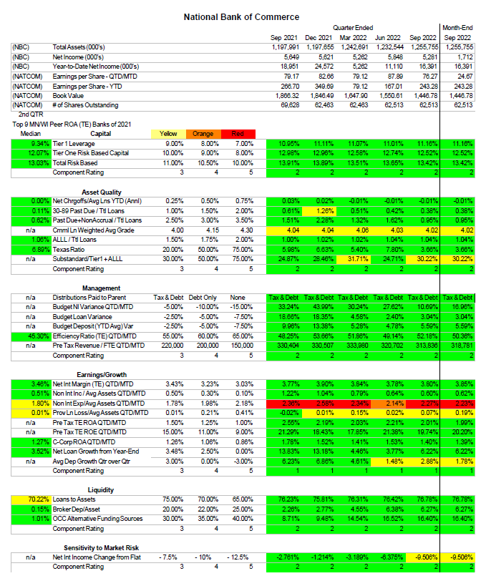

APPENDIX B: QUESTIONNAIRE/SURVEY QUESTIONS FOR BANK CUSTOMERS

1. How long have you been a customer of NBC?
a) < 1 year
b) 1-5 years
c) 5-10 years
d) 10+ years
2. Are you satisfied with the way the bank treats you as a customer?
a) Very dissatisfied
b) Somewhat dissatisfied
c) Somewhat satisfied
d) Very satisfied
3. With all required documentations provided, are you satisfied with how long it takes
for the bank to open a new account for you?
a) Very dissatisfied
b) Somewhat dissatisfied
c) Somewhat satisfied
d) Very satisfied
4. With all required documentations provided, are you satisfied with how long it takes
for the bank to process and disburse you loan application request?
a) Very dissatisfied
b) Somewhat dissatisfied
c) Somewhat satisfied
d) Very satisfied
5. How will you rate the bank’s response time to issues you raise?
a) Very dissatisfied
b) Somewhat dissatisfied
c) Somewhat satisfied
d) Very satisfied
6. Overall, how would you rate the products the bank is offering to you?
a) Very dissatisfied
b) Somewhat dissatisfied
c) Somewhat satisfied
d) Very satisfied

APPENDIX C: QUESTIONNAIRE FOR CHIEF FINANCE OFFICER (CFO)

1. Have you heard of the balanced scorecard concept before this project?
a) YES
b) NO (X)
2. Has the implementation of the balanced scorecard assisted in your corporate strategy
implementation and performance measurement?
a) YES (X)
b) NO
3. Have you observed an impact of customer perspective on the performance of your
bank?
a) YES (X)
b) NO
4. Have you observed an impact of financial perspective on the performance of bank?
a) YES
b) NO (X)
5. Have you observed an impact of internal business process perspective on the
performance of your bank?
a) YES (X)
b) NO (0)
7. Have you observed an impact of learning and development perspective on the performance
of bank?
a) YES (X)
b) NO (0)

APENDIX D: QUESTIONNAIRE FOR HUMAN RESOURCES DIRECTOR

1. How many associates with more than one year of service have left the organization in the
last one year?
- <10%
2. What was the total number of associates with more than one year of service in the last one
year?
- 71%
3. What is your associate turnover?
- Teller 41% NBC <15%
4. Does the bank organize induction course for newly recruited associate?
- Yes, we have an onboarding for all new associates
5. What is the minimum educational requirement you required to become a teller,
customer service officer, or credit processing officer?
a) Undergraduate and above
6.Do you have annual training programs planned for each associate at the beginning of every
year?
a) YES
7.Averagely, how many training courses does an associate attend in a year that relates to his/her
job?
a) 1-3
8.Does the bank enforce that all associates attend the training programs they have been slated
to attend for the year?
a) YES
10. Does the bank have an intranet for its associates?
a) YES
10. Does the intranet contain information on the bank’s products?
d) YES

APPENDIX E: NBC ASSOCIATE SURVEY

Source: Engage- 15Five Partner Bank Associate Satisfaction Survey December Results
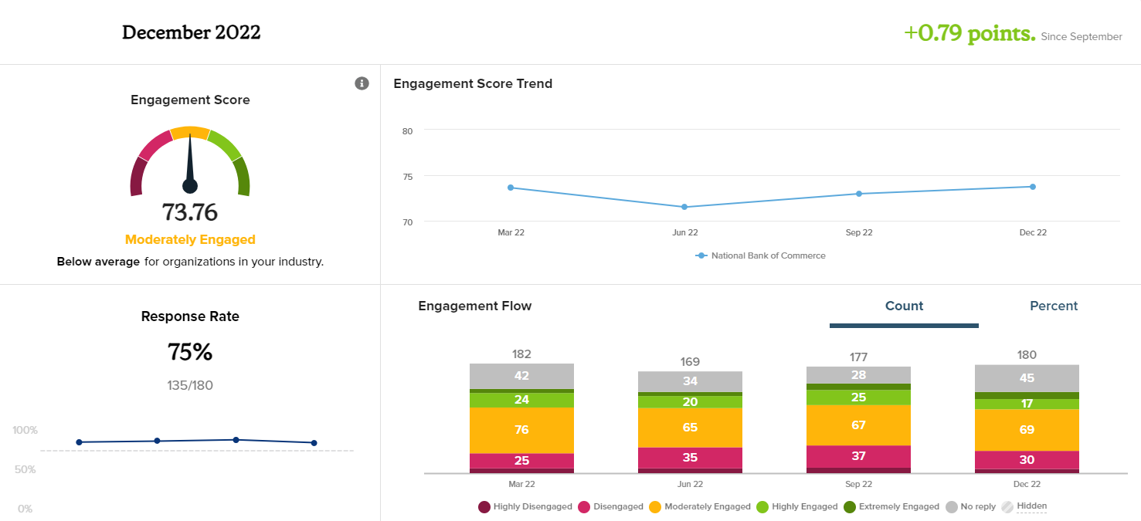

Role Clarity
A measure of the work experience and organizational culture. The organization connects associates' daily work tasks to the purpose of the business and provides clarity about what that work is.
Survey Questions
- Overall, I have a good understanding of what I am supposed to be doing in my job.
- I understand how my role fits into the purpose of the organization.
- There is a clear link between what I do and organizational objectives.
Purpose
A measure of the work experience and organizational culture. The organization communicates to associates why it exists beyond making a profit.
Survey Questions
- I have a good idea of what this organization is trying to accomplish.
- I know why this organization exists.
- I feel a shared sense of purpose with my department.
Capacity
A measure of the work experience and organizational culture. The organization enables associates to feel they possess the emotional and psychological resources necessary for investing themselves in their roles.
Survey Questions
- I am confident in my ability to handle competing demands at work.
- I am confident in my ability to deal with problems that come up at work.
- I am confident in my ability to think clearly at work.
Utilization
A measure of the work experience and organizational culture. The organization effectively uses associates' abilities and skills in their roles.
Survey Questions
- My job makes good use of my skills and abilities.
- My skills are being utilized to their fullest potential.
- My job challenges me in a positive way.

This concludes my report.

Kaplan R.S. and Norton D.P. (1992) The Balanced Scorecard – Measures that Drive Performance
Appendix A NBC Corporate Report Card
National Bank of Commerce KPI’s page 28
Appendix E: Engage – 15Five Emplify Results Associate Survey (2022)

